Resources for Adolescents and Young Adults

- SAFEUT Crisis and Tip Line App: The SAFEUT Crisis Chat and Tip Line is a Utah statewide service that provides real-time, emotional support and crisis prevention to youth through live chat and a confidential tip program. You can chat with a licensed counselor for support, or submit a confidential tip right from your smartphone, or call 833-372-3388 to talk about whatever is on your mind.

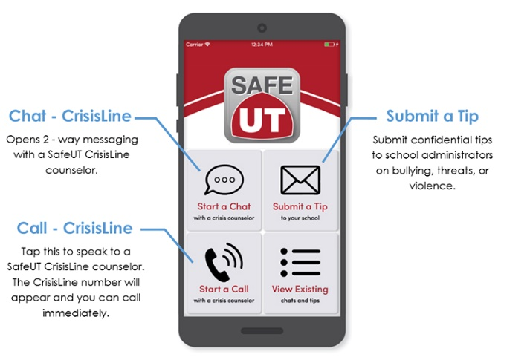

- NAMI Utah Progression: 6-week course for teens 13-18 years old with mental health conditions. https://namiut.org/our-programs/for-individuals/nami-utah-s-progression

- NAMI: https://nami.org/Your-Journey/Teens-Young-Adults

- Mental Health Resources for Adolescents and Young Adults https://www.adolescenthealth.org/Resources/Clinical-Care-Resources/Mental-Health/Mental-Health-Resources-For-Adolesc.aspx

- Primary Children’s Hospital: Emotional Well Being; Talk to Tweens www.talktotweens.com

- Mentalhealth.gov: https://www.mentalhealth.gov/talk/community-conversation/services

- TrevorLifeline: LGBTQ youth 1-866-488-7386

- Crisis Text Line: Text NAMI to 741741. Connect with a trained crisis counselor to receive free, 24/7 crisis support via text message.

- Reach: Teen Skills Classes and Activities. https://www.thereachprogram.com/ (Programing has been on hold because of COVID but is scheduled to restart in May.)

- Utah Suicide Prevention Coalition: www.liveonutah.org

- American Foundation for Suicide Prevention: www.afsp.org

